**Problem Statement- 1: Friend Affinity Finder**

**The Idea:**

Making new friends as an adult isn’t easy. It seems that everyone already has their friend group and they’re too busy to expand it. Simply meeting new people becomes increasingly rare.

Luckily, making new friends doesn’t have to entail removing the headphones of strangers just to see if they’re good friendship material or not. This web app helps users seek people who are similar to them in terms of personality traits and similar likes and dislikes by performing sentiment analysis and personality analysis (The Big 5) on twitter data.

**What is the uniqueness/novelty added by you to the defined problem statement?**

* Apart from searching for friends with a similar personality, the webapp also provides information about your Big5 analysis to understand yourself better.
* It also classifies your tweets into positive, negative and neutral for a user to analyse the kind of words he/she is putting out into the world.
* If a user does not wish to provide details of his/her twitter account they or they don’t have social media, they can still avail the services of the web app by taking our big5 personality quiz and find friends with similar traits regardless of their social media presence.

**How is the proposed solution impacting the business? How are the business processes simplified or bringing value over the existing process?**

The Big 5 Personality Model helps us understand the behavioural traits of a person. Coming to business, understanding personality can help identify and draw conclusions about consumer preferences, habits, and motivations.

If you think about that in the context of new products, branding, and advertising, it’s easy to see how leveraging the big 5 is a no-brainer.

Moreover, [Proceedings of the National Academy of Sciences](https://www.gutcheckit.com/learn/gcconstellation-robotic-vacuum-report-ty/) provides evidence that psychological targeting—such as targeting by personality—is likely to persuade the person to buy a product. Their research tests the difference between targeting viewers with ads based on whether they are extroverted or introverted: results show that when targeting viewers based on this, conversion rates double.

Based on our solution,

1. Travelling has become a part of the job culture. When you are in a completely new city getting to meet new people becomes difficult. This app helps you connect with people having a similar personality as yours.
2. For people trying to find a partner through matrimonial sites, it is always better if they know that the opposite person has a personality similar to theirs before meeting them.
3. Shifting to a new country for education may not be in your comfort zone. Finding similar minded friends help you feel like home.

So as you can see, personality is instrumental to how we behave. By learning more about consumer personality we can become more effective in targeting potential customers.

**Architectural flow of the proposed solution, with the mention of technologies to be used in developing the solution.**

**Flowchart:**

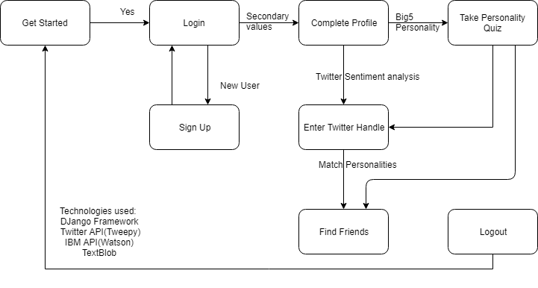

**Architecture:**

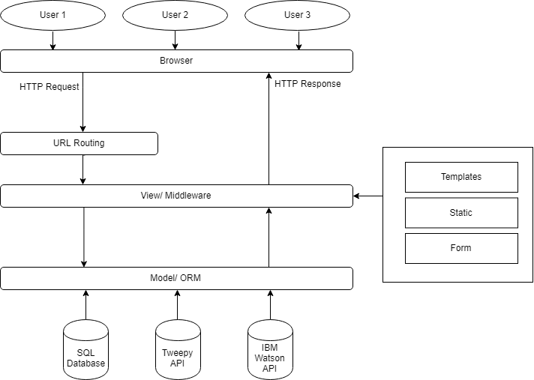

**Define the scope of work to be implemented in the project with modules etc.**

|  |  |  |
| --- | --- | --- |
| **Solution Scope** | | |
| **Scope** | **Description** | **Priority** |
| Social Media Presence | At the moment we have only considered twitter data for personality analysis, going further we would like to incorporate the users presence on other social media sites along with portals like Reddit, StackOverFlow, etc. | High |
| Filtering for Friends | The user should have an option to choose friends on the basis of some parameters if need be like location, gender, age range, etc. | High |
| Language Flexibility | The majority of the sentiment analysis takes place on english text, there should be provisions for analysis in different languages. | Medium |
| Chat Room Functionality | We do provide user email id as a means to initiate and carry forward communication with friends, but in service of privacy, a chat room on the website would be helpful. | Low |
| UI | The UI can be made more spunky for better user engagement. | Low |